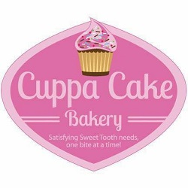
Cake Flavors
Funfetti (fruity accent flavor-Sprinkles in batter) * Top Seller
Chocolate
Vanilla
Marble
Wedding Cake (Almond)
Strawberry
Lemon
**Cookies and Cream
**Red Velvet
** Extra costs apply to these selections

Cake Fillings (extra cost)
**Nutella
**Raspberry
**Strawberry
**Lemon
**Pineapple (filling)
**Coconut Cream
**Chocolate Bavarian (filling)
**Ganache

Buttercream
Traditional
Chocolate
Almond
**Cookies and Cream
Peppermint
Peanut Butter
Cotton Candy

** Extra costs apply to these selections

